**MINI PROJECT**

**NUMBER SPECTRE**

**TEAM MEMBERS:-**

***Y.Praneeth (12K81A05J0)***

***Y.Keshav (12K81A05H9)***

***G.Vamshi Krishna (12K81A05D9)***

***L.Eswar Reddy (12K81A05E8)***

CLASS:- CSE-3C

COLLEGE:- ST.MARTIN’S ENGINEERING COLLEGE

INTRODUCTION

**Number Spectre is a number puzzle game.**

**A puzzle is a game or problem in which one is required to put pieces together, in a logical way, in order to arrive at the correct solution of the puzzle.**

**This puzzle consists of 4x4 blocks which contains numbers from 1-15 (which are jumbled) and an empty block or space**

**By making use of the empty block and using different move operations we have to arrange the jumbled numbers in order. This is the main aim of the game.**

**The different types of operations used are:**

* **right shift**
* **left shift**
* **up shift**
* **Down shift**

**The basic idea is to implement the above game in JAVA and converting it into a arcade game Android Application**

* **The game is finished when all**

***Proposed android system:-***

* **It is a Java application that is designed to work in Android operating system (above 4.0).**
* **The user interface deals with a set of random numbers from 0 to 15 if the 4*4 spectre is considered. The user is tasked to finish the game by arranging all the given randomly placed numbers in either a descending order or in an ascending order.**

**ARCHITECTURE:-**

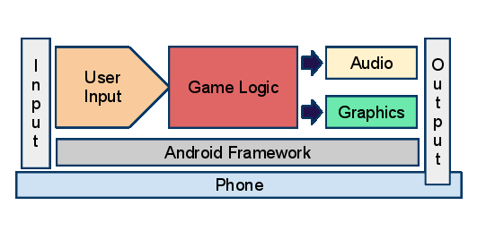

**UML diagram:-**

OPEN THE GAME

GAME ENDS

Move+1

Increment no.of Moves

Arrange blocks using shift operations

Start game

Select a Mode

All numbers in ascending order

**Software Requirements:-**

1. **Android mobile with a minimum version 2.2.**

**Hardware requirements:-**

1. **Processor is not less than 500MHZ.**
2. **RAM is not less than 170MB.**
3. **SD card with minimum of 512MB.**
4. **Resolution is not less than 480*800pixs.**